The Enterprise-class Operating System

To quote the famous Dave D, “An operating system is a collection of programs and files that manage a computer system’s hardware resources.” Operating systems come in a variety shapes and sizes, kind of like shoes, which vary from sandals to steel-toe construction boots. Even though all operating systems are responsible for managing the computer system’s hardware resources they differ widely in their capability to deliver effective management of these resources; so operating systems have similar responsibilities, but implement them differently. In our shoe analogy, think of wearing different shoes for different activities: sandals for relaxing, sneakers for running, dress shoes formal occasions, boots for working in the rain and snow and construction shoes for heavy-duty industrial work applications.

Operating system providers like Apple, Google, IBM and Microsoft developed their operating systems with specific design goals in mind. Apple, Google and Microsoft designed their operating systems, Android, OS X and Windows respectively, for the mass market for small, single user machines, where the expected users have little technology experience; so these operating systems need substantial overhead to make the computer system and its applications easy to use and where system failures where considered inconsequential. If the system fails, just “reboot” and start over. In our shoe analogy, think of these operating systems as scandals. IBM, on the other hand, designed z/OS as a hardened, very secure, high performance operating system for multi-user environments. It was designed to support the processing needs of thousands of users and user applications running concurrently and more importantly to “never” fail. Failures, slow response times and poor performance in this context are considered disastrous. The notion of just “rebooting” is not only undesirable; but in many circumstances not necessary. In our shoe analogy, think of z/OS as the “steel-toe construction” boots.

Operating systems also need the manage resources for a variety of workloads. Workloads can take on unique characteristics allowing us to categorize them as follows:
- Batch - generally long running workloads that mirror a business process, like payroll, where all inputs and outputs are predetermined and made available to the workload before the execution of any of its programs, can run independently without user intervention and can be scheduled to run when needed or convenient to the mix of other workloads that need to be run. Batch workloads run in units of seconds, minutes or hours. Your COBOL compiles and Lab program executions are run in batch mode.
- Online - generally smaller units of work that represent transactions, require user intervention, often not scheduled and where inputs are provided at the time of execution. Think of an ecommerce application, like online order entry, as an example of an online workload. Online workloads run in units of sub-second to 3 seconds. Anything you do in ISPF is run as an online transaction.
- Real-time - a variation of online where the workload is running always executing getting a continuous stream of input and responding to those inputs immediately with outputs. Think of air traffic control systems, defense systems for missile guidance, automobile anti-lock breaking systems and manufacturing systems using automation, like robotics. Real-time workloads run in mille-to-micro seconds. Your editing of your COBOL program in RDz is considered a real time activity.

The unique design of an operating system determines the effectiveness of processing the various kinds of workloads. z/OS has four main user interfaces that allow the user to explore and use z/OS services.
- TSO - Time Sharing Option is the command line interface that requires the user to type in specific commands. These commands can be scripted making it easy to do repetitive tasks. TSO has very little overhead so the user can perform tasks very quickly. The downside is the user has to learn specific commands to get z/OS to do what the user wants the operating system to do. You can think of the Windows cmd capability as the functional equivalent to TSO. TSO commands are generally executed interactively but can also be executed in REXX scripts and in batch jobs which Windows doesn’t support.
- ISPF - Interactive Systems Programming Facility is the menu-based interface. ISPF can perform many of the same tasks as TSO, except scripting. ISPF is easier to use since all of the commands are the result of choices displayed to the user. So the user needn’t worry about memorizing specific commands. ISPF has more overhead that TSO, so expect some minimal performance degradation. The Windows equivalent is the tool bar (minus the icons.) ISPF menu choices can be “piped” so the user can string multiple menu selections together separated by a semi-colon allowing the user to execute multiple selections. An example for looking up the status of a particular started task like the host resident portion of RDz, RSED, would look like this: SD;ST;FIND ‘RSED’
- RDz - Rational Developer for System z is the graphical user interface that allows the user to use z/OS services by using icons, mouse, drag & drop, cut & paste and right click for menu drop down choices. It is the functional equivalent of the Windows user interface. Graphical user interfaces are easier to use but carry significant overhead and are generally offloaded to separate computer systems for processing. Determining the location of the mouse cursor requires a get deal of overhead that enterprise operating systems use for other purposes like transaction processing.
- RD Traveler – Rational Developer for System z lite. This is a browser-based interface with many of the functions and features or RDz but doesn’t require the installation of addition software. You access z/OS through your favorite browser.

In this lab, we will explore the major components or services provided by an enterprise-class operating system. Our learning objectives will be as follows:
Learning Objectives
The student will be able to:
- Define an operating system
- Describe the purpose of an operating system
- Explain the basic uses of an operating system
- Describe some of the basic operating system services
- Use z/OS user interfaces RDz and TSO/ISPF to explore z/OS services
Resources - Blackboard, Lab Resources and JCL Workshop
z/OS Introduction, http://www-03.ibm.com/systems//z/OS/
Lab Exercise
In this lab you will explore the capabilities of z/OS, an enterprise-class operating system.

- Let’s use z/OS’ ISPF Primary Option Menu as our navigation system. Here you can see a classic menu interface. From here we can see there are a number of services provided. Since “More: +” is displayed on the first page of the menu we know that we can press the F8 key to scroll down to see the remaining services available to us.

By typing the menu selection, listed in the right-hand column, on the “Option ===>” line and then pressing enter you can direct z/OS to perform that task.

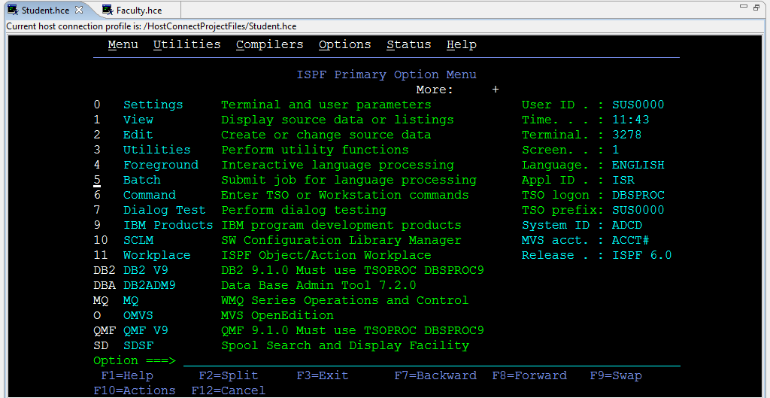

- From the ISPF Primary Option Menu let’s see if we can find out what security services are available. Locate the Resource Access Control Facility, RACF. RACF is the security system (sometimes called an enabler) that plugs into z/OS’s System Access Facility (SAF.) RACF is also referred to as an External Security Manager (ESM.) The SAF interface allows z/OS to use one of a variety security systems to manage the system’s resources. We use RACF; but we could have selected another security product in the marketplace or written our own that was unique to our security needs.

From the RACF - Services Option Menu, explore the various options. By inspecting the choices available to you what can you determine how the operating system secures the hardware resources?

Your RACF sub-menu will look like this.
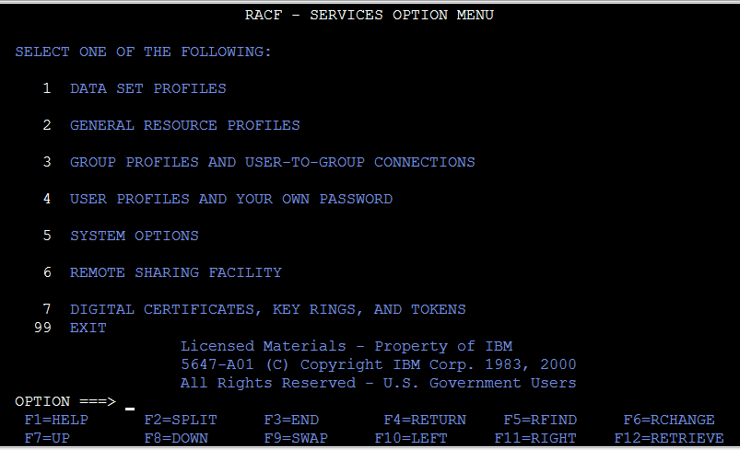

- Use F3 to take you back to the Primary Option Menu. Let’s explore the Spool Search and Display Facility. This time let’s “pipe” our selections. Let’s assemble the commands needed to find your TSO session located in the Spool Search and Display Facility, status of all jobs. Using “F” for find our piped commands will look like this: SD;ST;F ‘SUS0000’ in this command use your ID, not SUS0000. Keep in mind we could have submitted each of these as 3 separate commands. Your results will look similar to this:

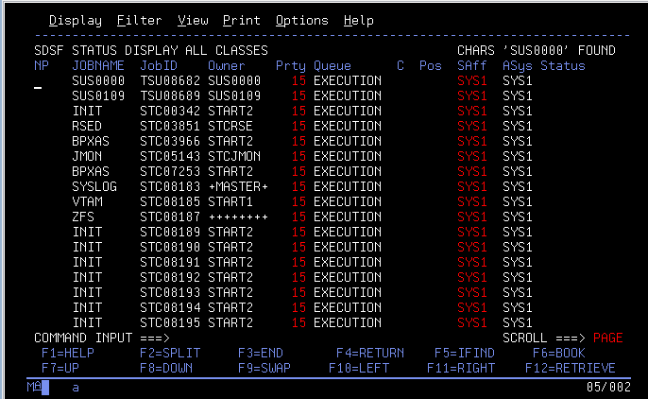

From here select F3 to take you back to the SDSF sub-menu. Select DA for active users. This screen will display all of the active jobs running under z/OS. Many of these are not actual users but “Started Tasks” similar to the ones that Windows launches on start up based on the information in the Windows Registry. z/OS uses the “SYS1.PARMLIB(IEFSSN00)” dataset to do the same thing. At Initial Program Load (IPL or bootstrap) z/OS looks for programs to launch at startup launching jobs that provide various services for the user or user’s programs.

Also, Linux and Unix (and variants) have a similar feature called Daemons. After you select DA, you should see a screen that looks like this:

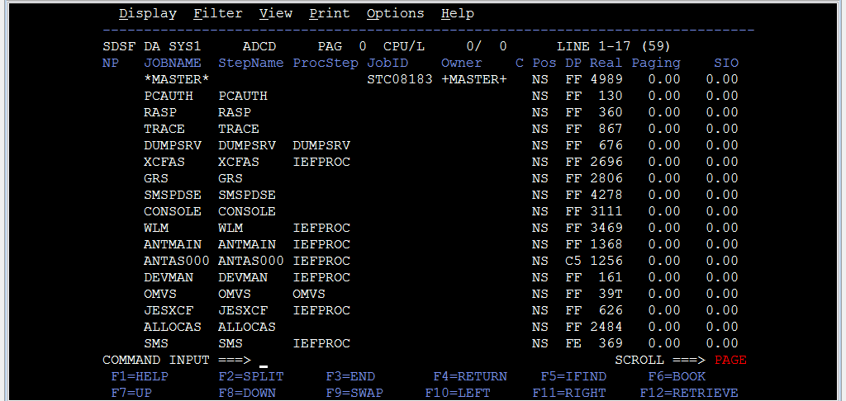

When I captured this screen you will notice that there are 59 active jobs running. Yours will be different since everyone in class will have an active job as a result of the logon process.
By going to 3.4 let’s find the “SYS1.PARMLIB(IEFSSN00)” dataset to see how z/OS determines which started tasks to launch. Here you can see that RACF is launched on startup. Page down to see if you can recognize any of the other started tasks.

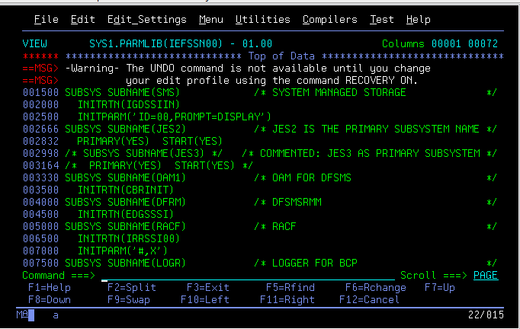

Her you can see that Unix and ISPF are also tasks that are launched at startup.

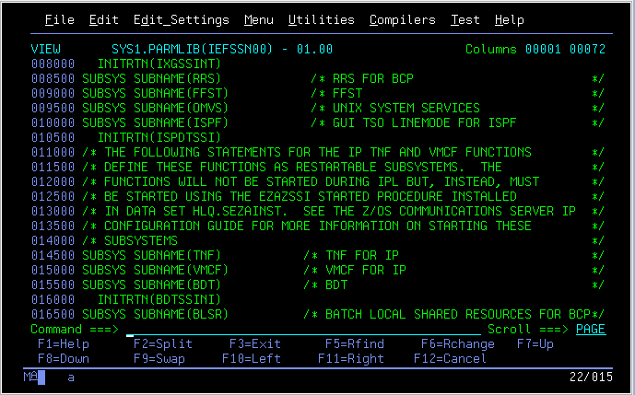
If you press F3 you can take yourself back to the main menu. Here you can see there are two pages (screens) that contain the services offered by z/OS. Acquaint yourself by exploring some of these other services. As a side note, there is no functional equivalent of ISPF in Linux or Unix.

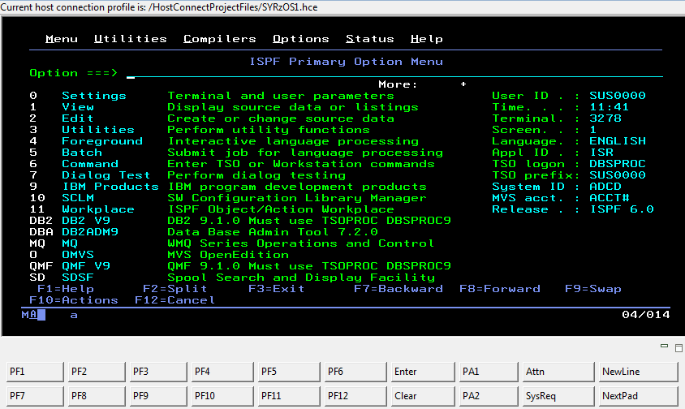

One last think to point out, when you learn the menu options and know pretty well, you can navigate from any screen to any other screen by placing the equal sign (=) in front of your menu choice. Here is an example, =3.4 will take me directly to the Data set List Utility.

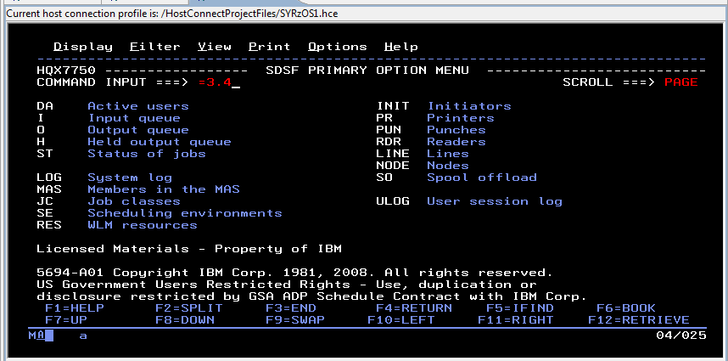
Here you can see that I went directly to the screen I wanted without having to navigate to the main menu.

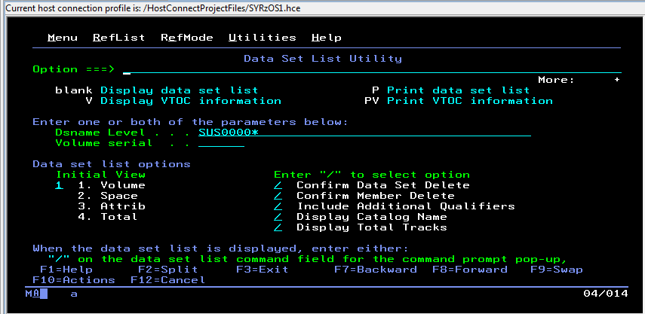
Please type your answers and attach the requested output results from your COBOL program. (20 points)

- a. Define an Operating System? b. Describe some of the services it provides. (2)
a. __________________________________________________________________
__________________________________________________________________
__________________________________________________________________
b. __________________________________________________________________
__________________________________________________________________
__________________________________________________________________
- Describe the three (3) main workloads that an operating system must manage. (3)
a. ______________________________________________________________________
______________________________________________________________________
b. _____________________________________________________________________
______________________________________________________________________
c. ______________________________________________________________________
______________________________________________________________________

- Number 4 of this lab exercise has you building a COBOL program. Identify which workload type (batch, online or real-time) as a result of the each of the following actions. To help you answer these questions ask yourself am I getting instantaneous feedback or is there a delay? (5)
a. Typing COBOL code into the RDz editor__________________________________
b. Running a COBOL compile_____________________________________________
c. Running your execution JCL to test your compiled program__________________
d. Using ISPF, SD to check the status of your compile__________________________
e. Using ISPF, SD to check the status of your program execution_________________

- Stalking No Arrest Report. (10 points)
The new ABC television series, Stalker, staring Maggie Q and Dylan McDermott has caused a firestorm of questions on the stalking situation in Chicago. Chicago’s new Police Chief wants a report to support his theory that the Chicago Police Dept. is doing a good job combating stalking. Write a COBOL program named LAB6 that supports or undermines the police chief’s claims:
- Display a splash page that has the following items:
- GET239 Enterprise Technologies LAB6
- Your name (First & Last)
- Date
- Surround the splash page with asterisks

- Use the crime record file descriptions from SHARE.GET239.COBOL(LAB5REC)

- Read the 2009 and 2010 crime files (SHARE.CHICAGO.CRIME09 and SHARE.CHICAGO.CRIME10) sequentially as one file.

- Count the total number of records read, the 2009 crime records and 2010 crime records all as separate counts.

- Stalking - Select for processing all stalking categories

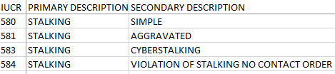

- Calculations - Count the following:
  - All stalking crimes (580, 581, 583, 584)
  - Simple stalking (580)
  - Aggravated stalking (581)
  - Cyber stalking (583)
  - Stalking violations (584)
  - Number of Stalking crimes resulting in no arrest (CC-ARREST = ‘F’)
  - Percentage of no stalking arrests (be sure to round your results)

- Detail Report - Produce a report with both a report heading and column headings. List each selected crime record showing date-time, address, primary crime, crime description and arrest code for stalking crimes where there was no arrest made (CC-ARREST = ‘F’)

- Summary Report - After you have processed all of the records, display the total number of crime records read for 2009 and 2010 and the totals calculated in letter f above

- Deliverables - Submit with the answers to the questions above:
- Your LAB6 source code
- Screen print from your RDz LOADLIB showing your LAB6 load module.
- Output reports from the LAB6 execution that proves it works, be sure to verify your results. Just because your program runs doesn’t mean the output is correct.
-------------------------------------------------------------------------------------------------------
Specifics on the EVALUATE statement.

The EVALUATE statement is a very powerful command that allows you to test for a number of conditions with a single command. The EVALUATE also allows you to avoid complex logic normally seen in some languages that have complex nested IF, THEN, ELSE logic. You will find the EVALUATE very useful in your Lab 6 exercise.

Here is an example of the EVALUATE statement:

EVALUATE JOB-POSITION
WHEN 'MANAGER '
ADD 1 TO MANAGER-COUNT
WHEN 'ANALYST '
ADD 1 TO ANALYST-COUNT
WHEN 'DEVELOPER '
ADD 1 TO DEVELOPER-COUNT
WHEN 'TESTER '
ADD 1 TO TESTER-COUNT
WHEN OTHER
MOVE 'Must be an IT position' TO ERROR-MESSAGE
END-EVALUATE.
Think about where the EVALUATE instruction can be useful in counting your stalking crimes.
Your reports should looks something like these on the next page:
Your Detail Report

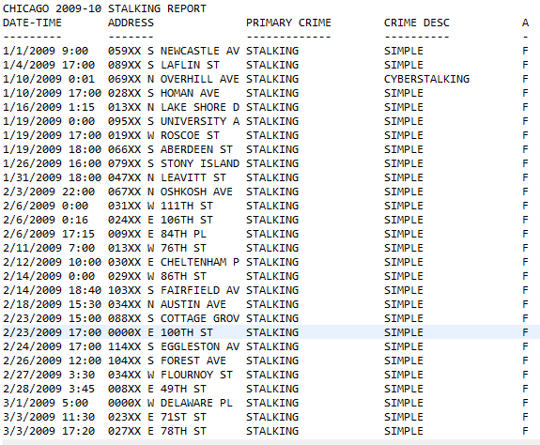

Your Summary Report

******************************************
* GET239 Enterprise Technologies LAB6 *
* <your name here> *
* <the date> *
******************************************
2009 Recs Read : 391,302
2010 Recs Read : 369,563
Total Recs Read : 760,865
-------
Stalking-Simple : 315
Stalking-Aggravated : 14
Stalking-Cyber : 28
Stalking-Violations : 0
All Stalking : 357
-------
No Stalking Arrests : 305
No Arrest Percent : .85
******************************************
* End of Chicago Stalking Report *
******************************************

